**5 sample screens most relevant to the problem statement**

So as our problem statement is basically designing a website for individual small scale business-owners and stores so that they are able to represent their unique brand values and identities and stand out to survive at a time when the tech giants brand themselves and their product so well that the uniqueness of these small stores and businesses gets faded.

So for our project we decided to work on a Food ordering website which will achieve all the goals stated above.

**Screen1:** The first goal is to market the brand itself to the general Audience:

So moving with the name Curry Island we designed the homepage of our store website in a way which attracts our customer base and at the same time represents the overall purpose and the idea which we want to deliver to the users that is the our clients.

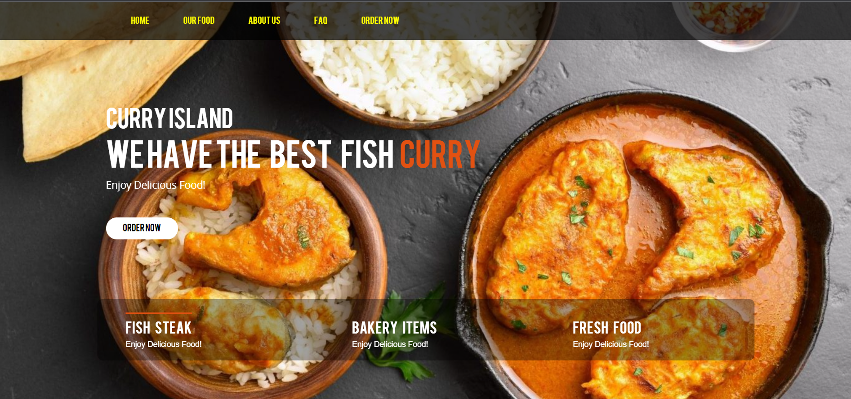

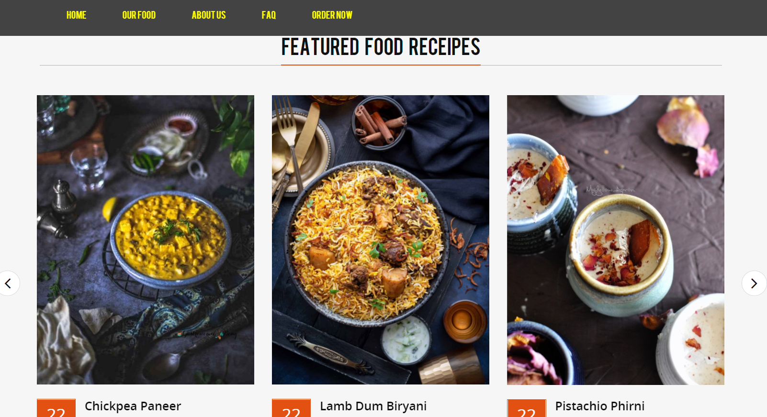

**Screen 2:**

Next task that we need to take care as per the problem statement is to handle the obvious navigations/options that any legitimate user would like to know about including the services that we provide.

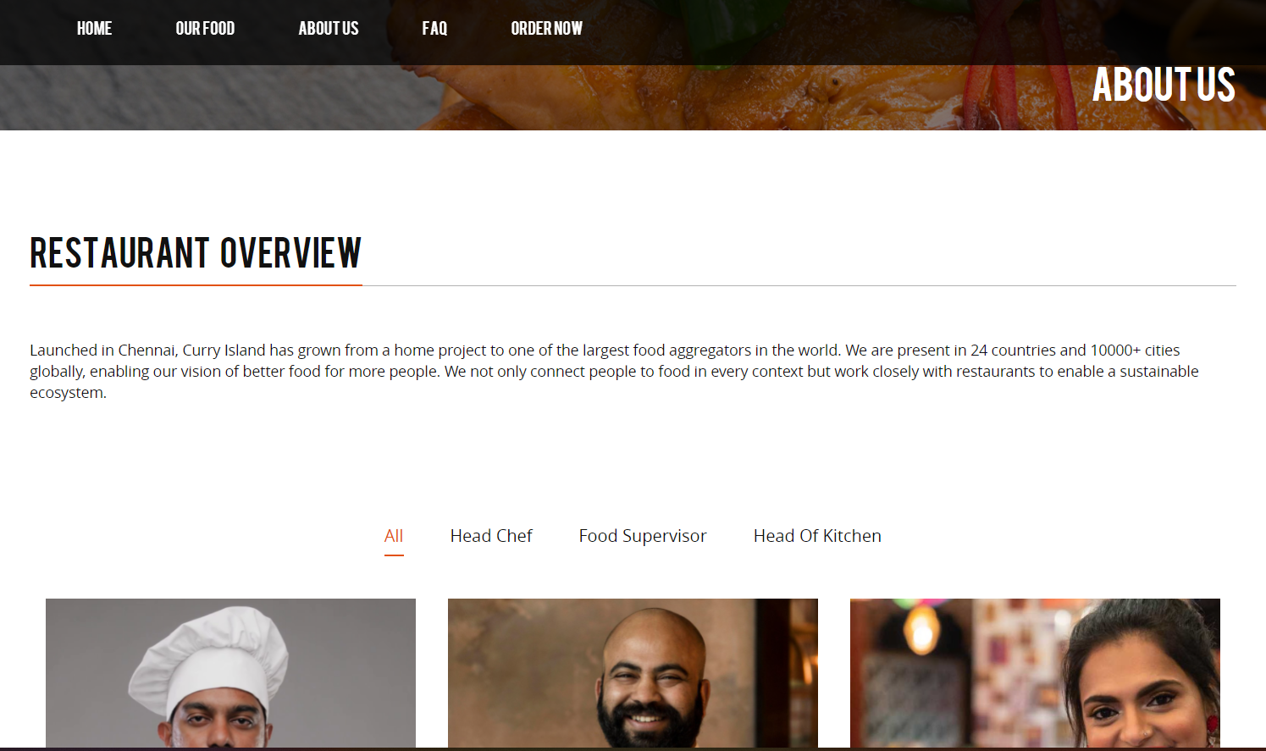

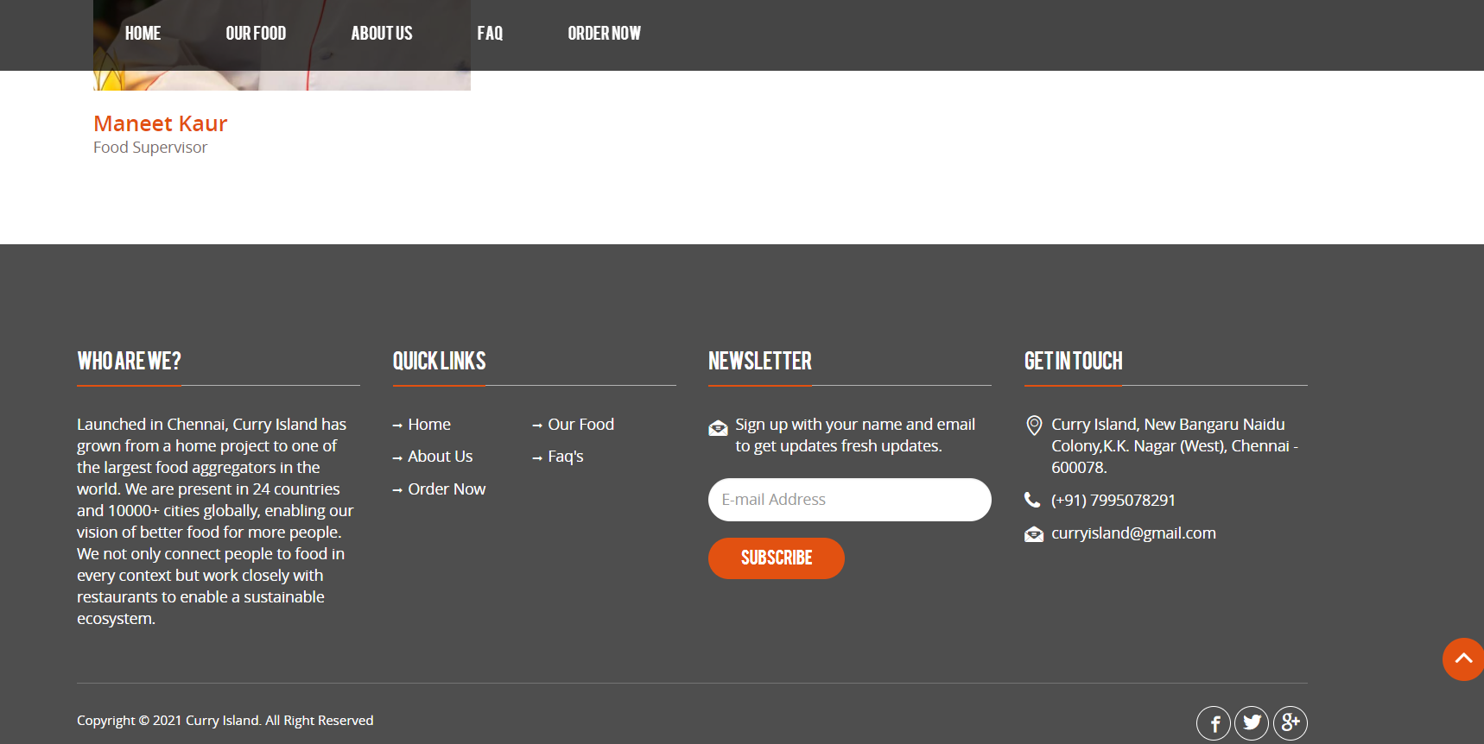

So for this purpose we built a separate about us page and designed a footer as shown containing all the relevant and required options that a user need to know about our services.

**Screen 3:**

The third task is to get the user familiar with the knowledge about what’s currently in store for each of them and to handle the questions that a lot of users faces about our services so for that purpose we build and designed the Our food section for the former and the FAQ’s section for solving the later task.

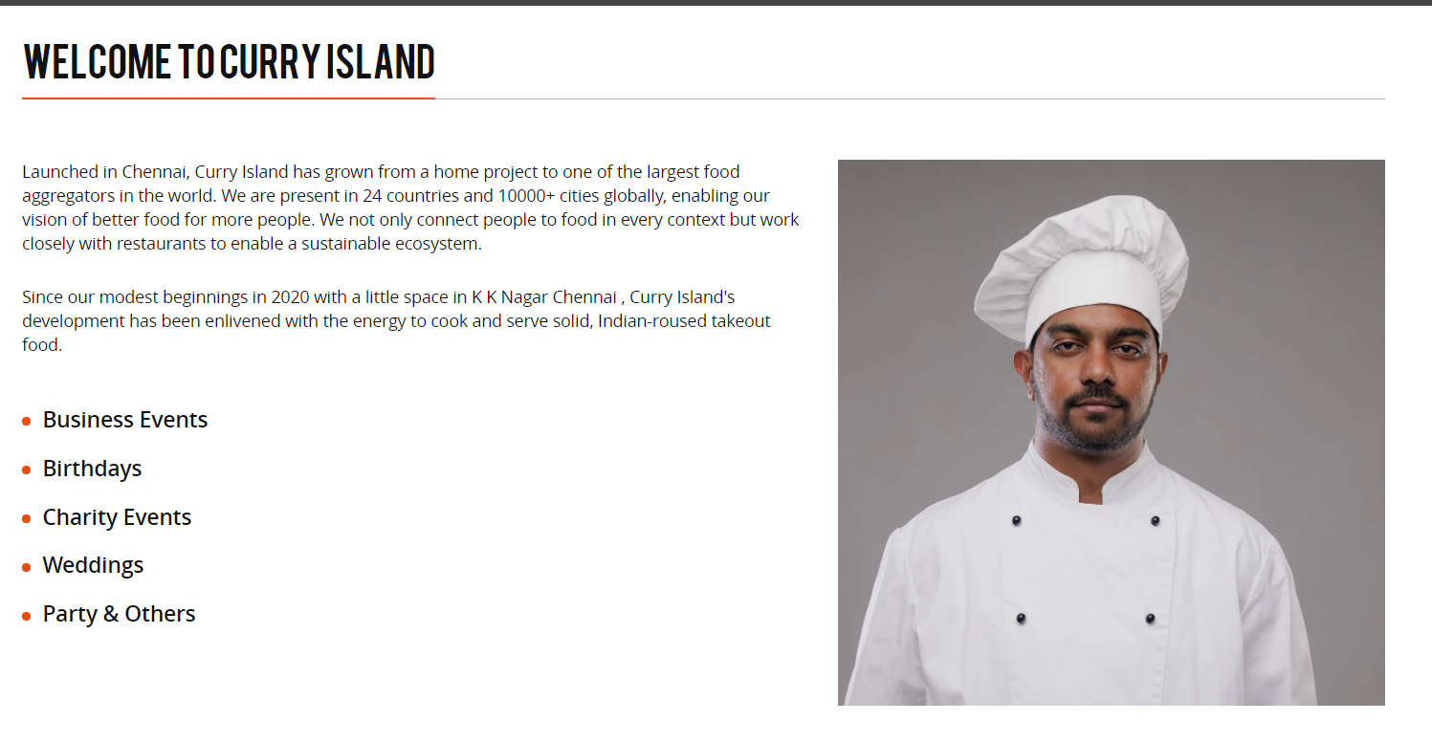

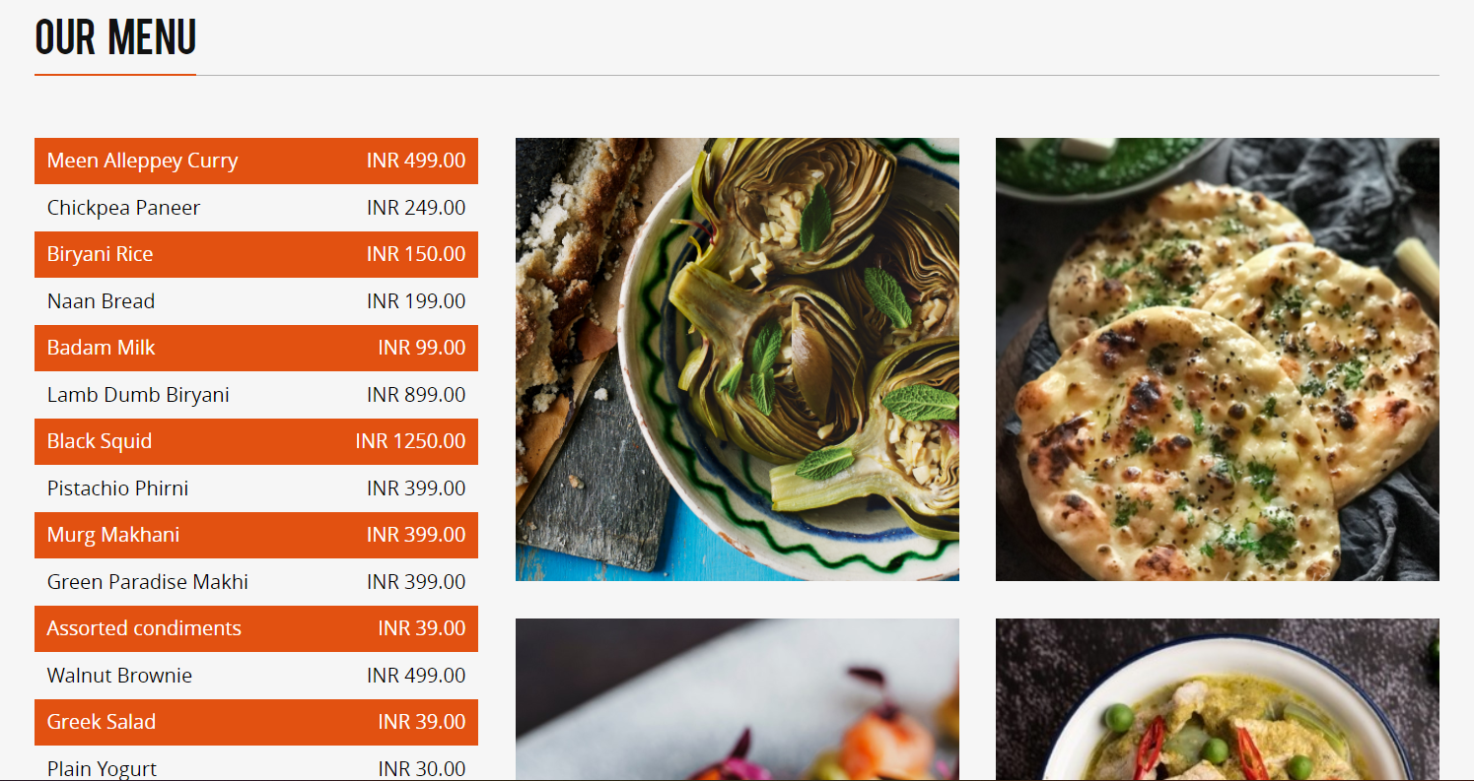

FAQ’s section:

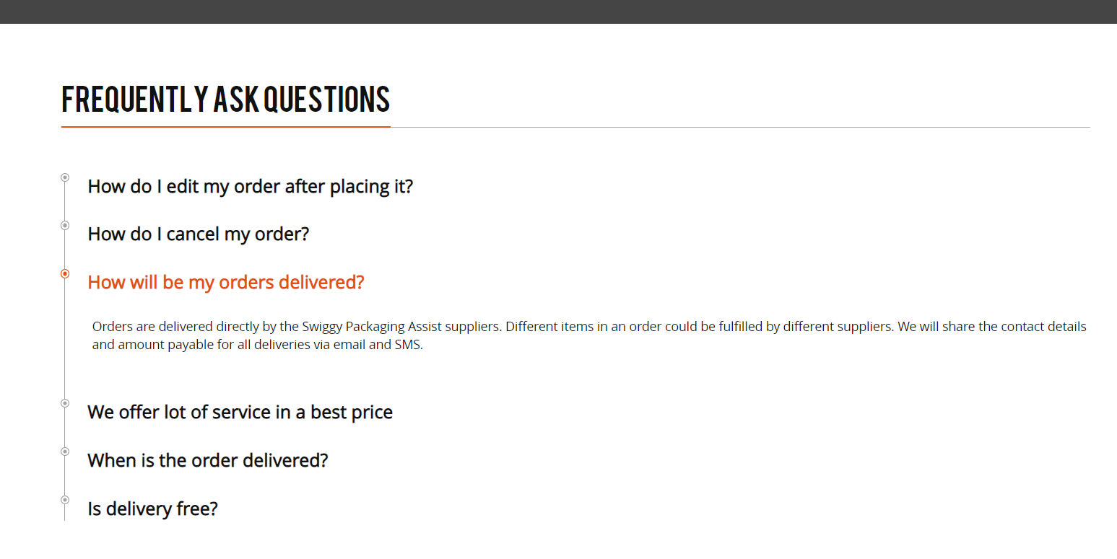

**Screen4:**

The next major task was to provide the user a very pleasant as well as easy experience at the time they place an order. Most of the users as we see during requirement analysis that finds the order section either confusing or not containing all that is required by the user so we take all that into consideration and designed the user section in a way that it is extremely easy for any user to order as well get all the options that a user can ask for.

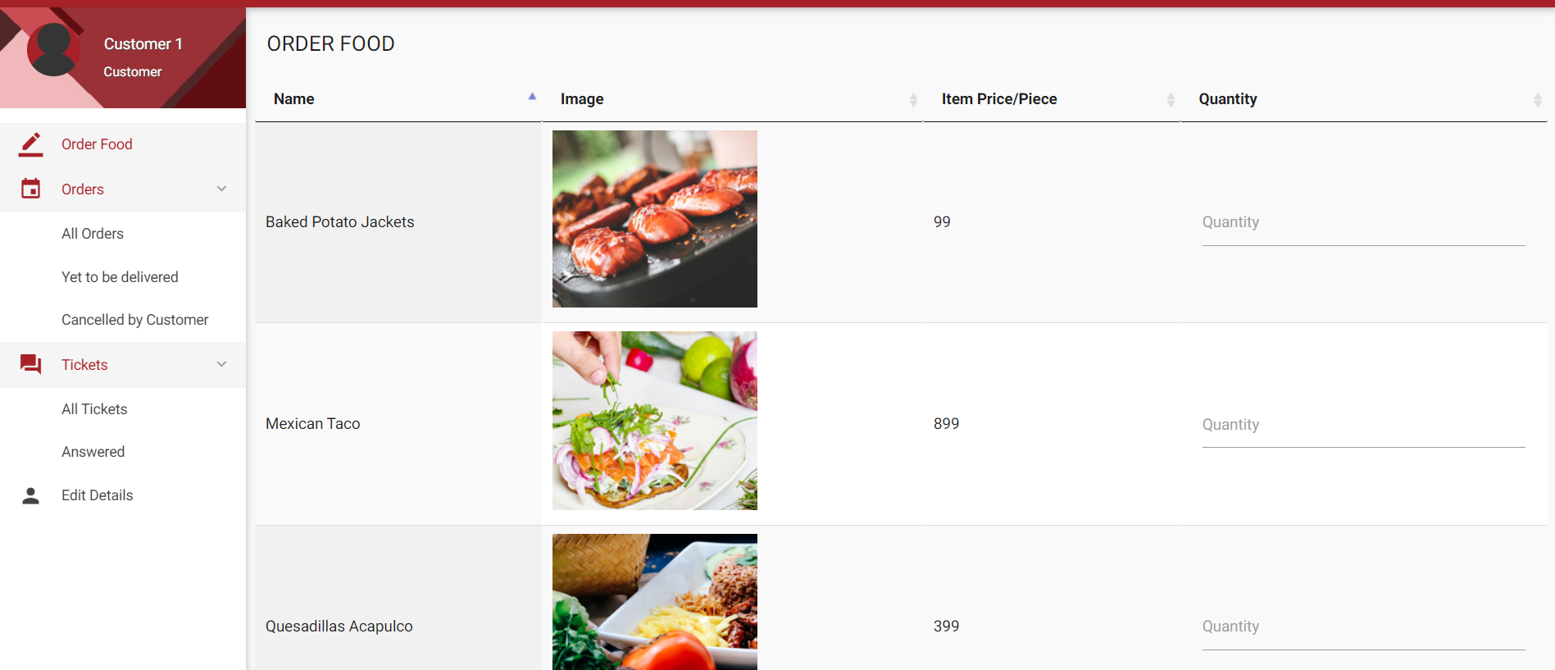

**Screen5:**

The last screen is based on the interface that the admin requires for smooth and continuous functioning of our platform. So using the concept of commonality and generalizability we designed an interface for the admin of our platform.

All the required options that the admin needs in order to resolve and add changes from his side are properly designed.

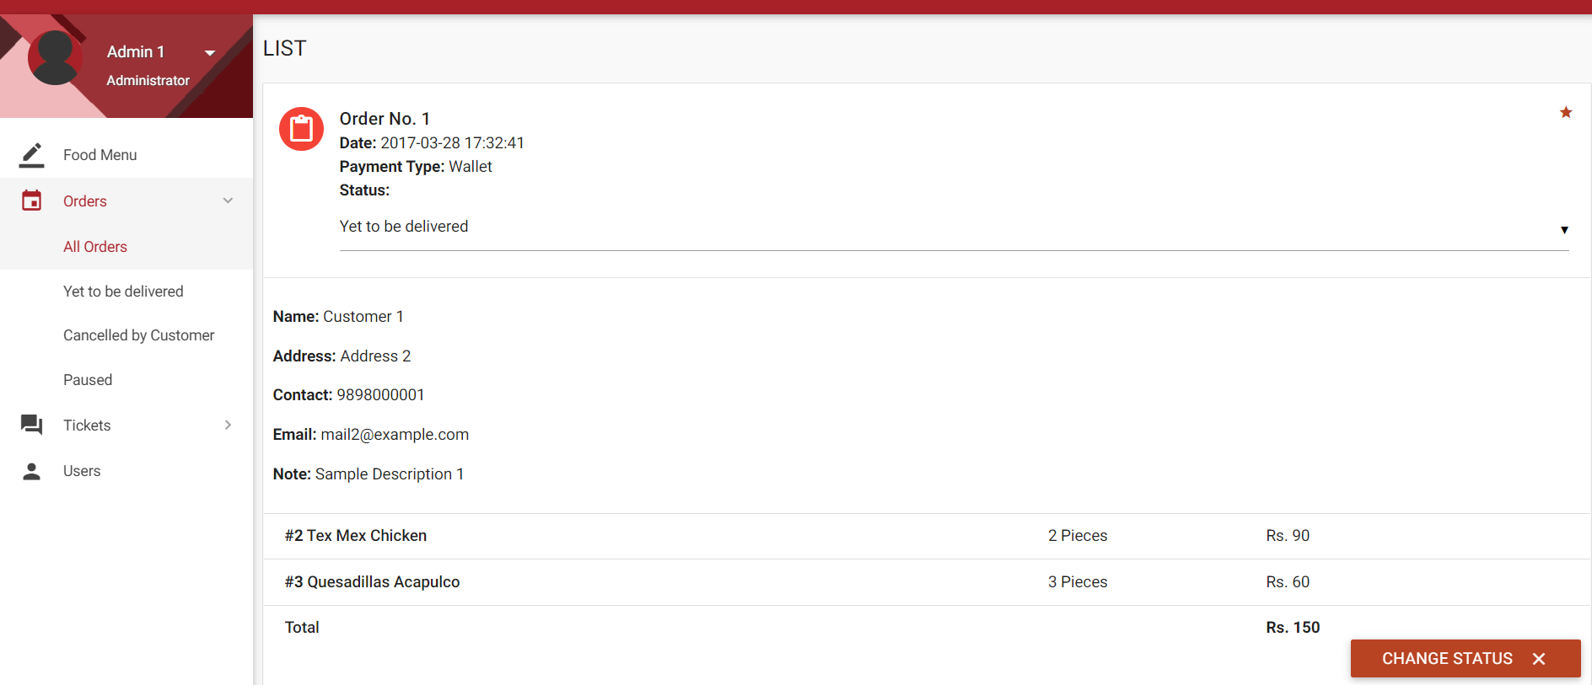

Heuristics: First three🡪

**#1: Visibility of system status**

**The design should always keep users informed about what is going on, through appropriate feedback within a reasonable amount of time.**

*Our website regularly tells the user about the current items in the cart.*

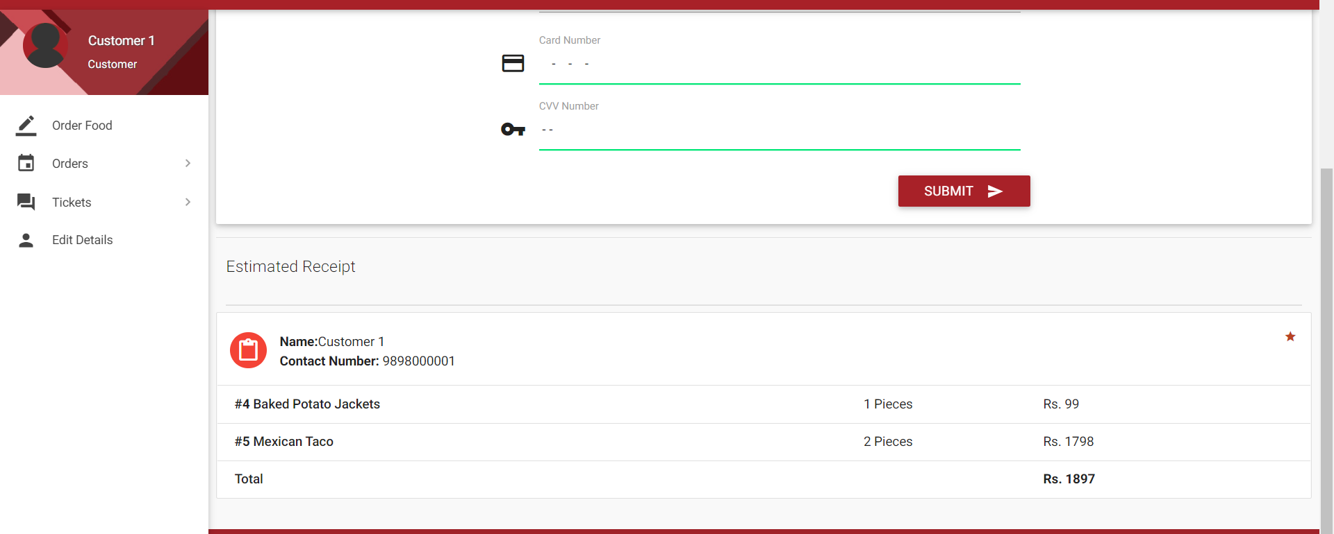

The user also gets to see the status of tickets he raised at any point:

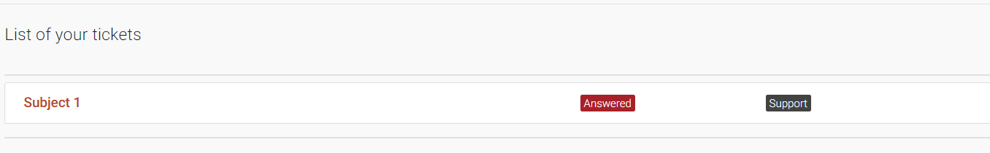

Consistent animation for loading of all sections and pages so that user knows about the system status anytime:

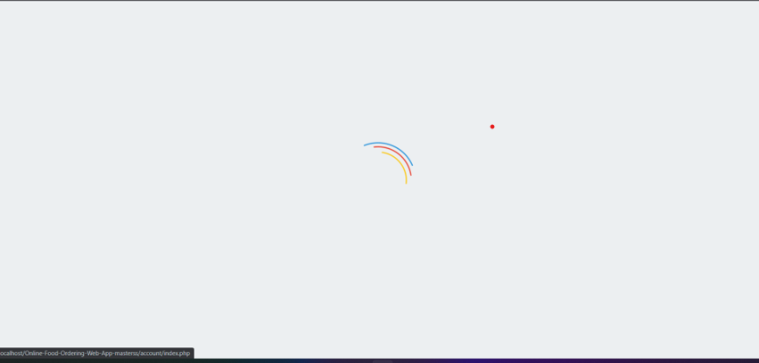

**#2. Match between system and the real world**

**The design should speak the users' language. Use words, phrases, and concepts familiar to the user, rather than internal jargon. Follow real-world conventions, making information appear in a natural and logical order.**

*We display pictures of food items so that it is easy for the customers to recognize and decide what to order.*

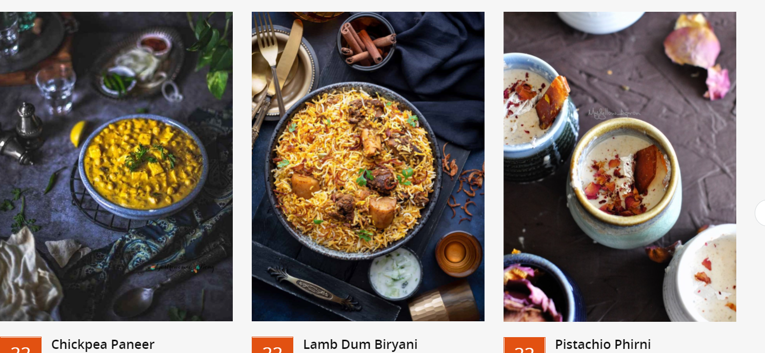

*We use icons that are easy to understand and are close to real life.*

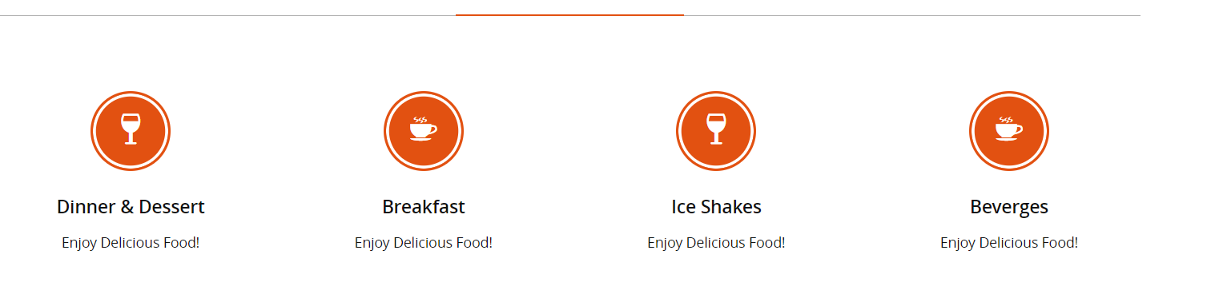

We also added a FAQ’s section to our design to achieve this task:

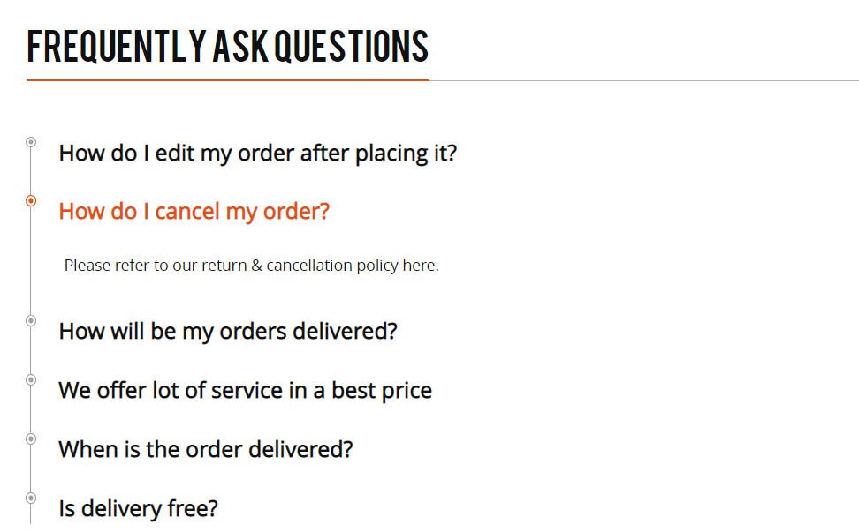

**#3 User control and freedom:**

**Users often perform actions by mistake. They need a clearly marked "emergency exit" to leave the unwanted action without having to go through an extended process.**

*We have incorporated and included a edit details section so that in case any user commits a error they can reverse it any time they want.*

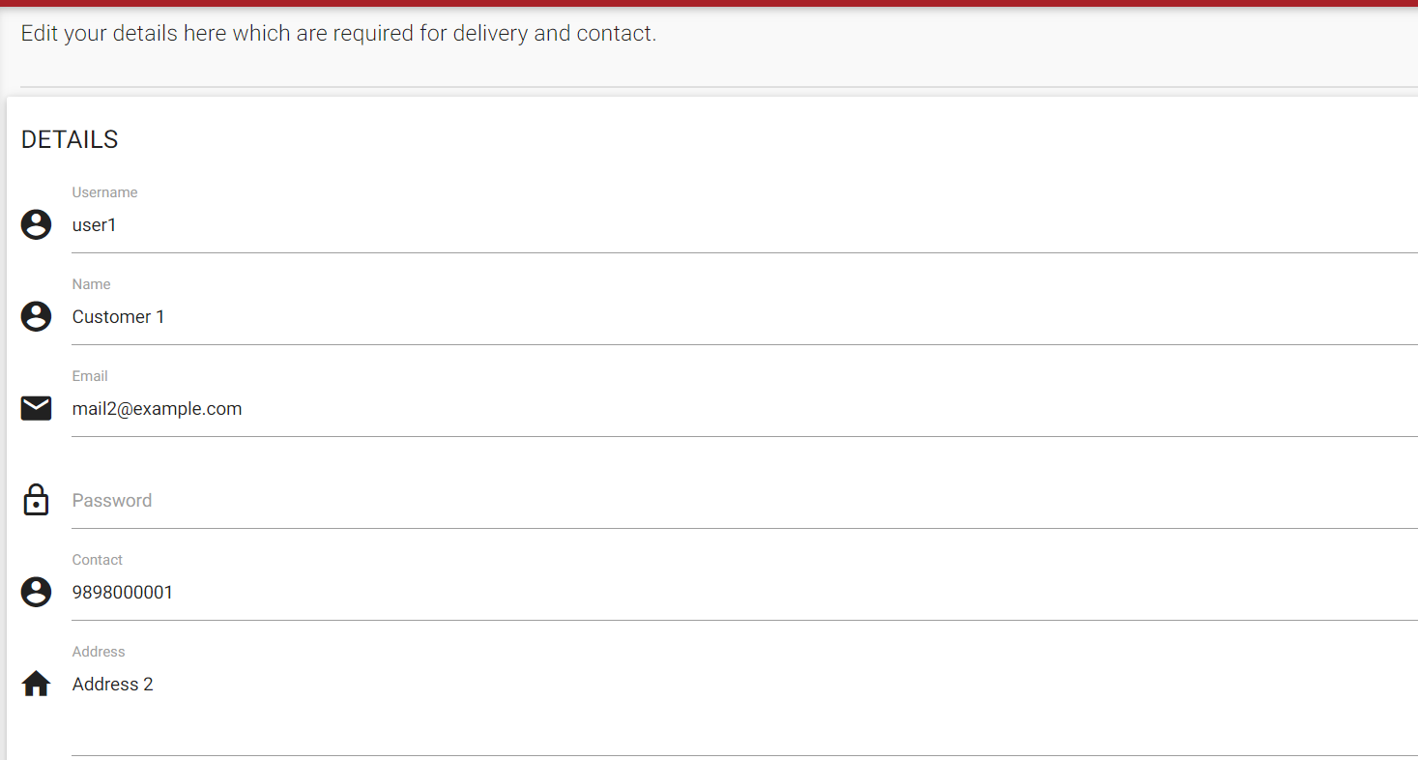

We have also added